
Parenting NEWS
Ideas that work with kids!

S I B L I N G I S S U E S
FOR TODDLERS, PRESCHOOLERS & ELEMENTARY AGE CHILDREN
Let’s face it, siblings ﬁght–some ﬁght more than others!!! There are important factors that contribute to rivalry: temperament, gender, age differences, interests, talents, social/emotional abilities and issues. Parents are instrumental in helping their children get along better and here are some tips
to make things easier:
- Recognize that it is very difﬁcult for children to share their parents’ attention. Every child wants to be loved ONLY. Since this is not possible when children have siblings, help them by acknowledging and understanding their feelings (“I know it is hard for you when it’s your sister’s birthday and she is getting so much attention. I understand.”).
- Help your children learn to communicate and solve problems by serving as their coach (“I see that you are having difﬁculty sharing the blocks. Let’s talk about how you can cooperate and each have some blocks to play with. What are your ideas?”). Young children need the coaching– the tools and strategies taught to them by parents–before they can handle situations on their own.
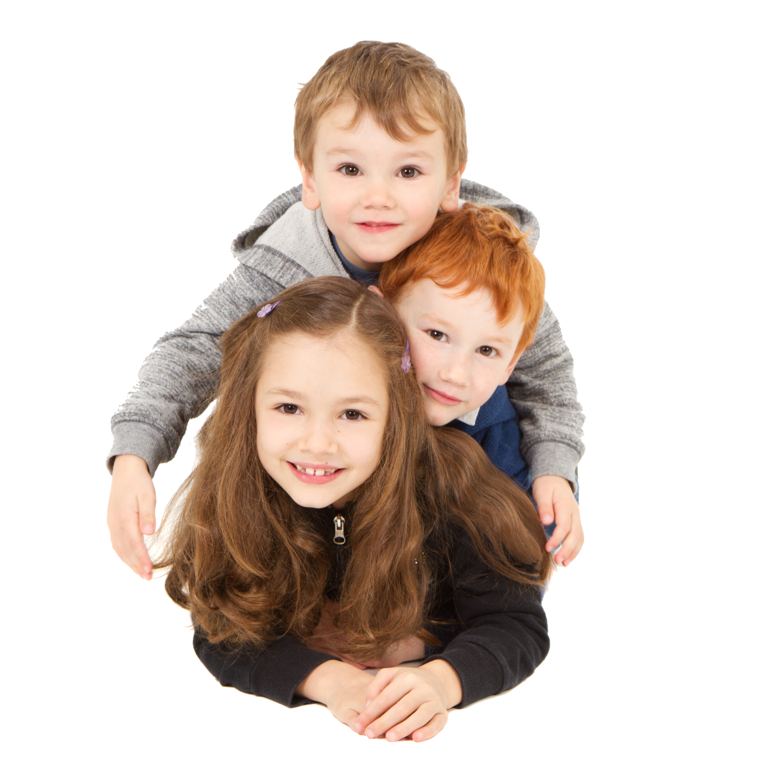
- Notice when they are getting along and give lots of kudos for positive interactions with one another (“You both did a great job taking turns with the legos. I heard you using words and listening to each other. Good for you.”). Give more attention for the positive and less
for the negative behaviors.
- Have one-on-one time with each child, regularly. This “Special Time” helps children know that they get your undivided attention several times during the week. This time is best spent doing something interactive–playing board games, card games, ball games, building with blocks, taking a walk, coloring. When children know they get mom and dad alone several
times a week, they tend to act out less.
- Establish a “Kid of the Day” routine by keeping a calendar and having
children take turns being “kid of the day”. They are “kid of the day”
every other day–or every third day–depending on the number of
children in the family. The “kid of the day” gets to decide things that
children naturally ﬁght about: who showers ﬁrst, what movie they are
going to watch, who gets the ﬁrst brownie out of the pan, etc. This is a very
practical way for parents to not get sucked into bickering and arguing. All you
have to say is,” Who’s “kid of the day”? Oh–Jeremy is. He gets the first brownie.”
Kids abide by this, and they really like it!
N A N C Y C O H E N
m.a.
child development
& behavior specialist
For more information: 619-992-0703

